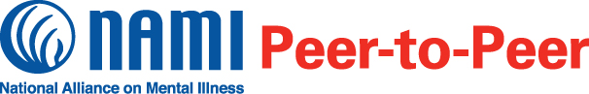

**Registration extended to early Feb. 2022!**

**A new class starts Sat., 10:00 a.m., Feb 5, 2022, and goes through March 26.**

NAMI Peer-to-Peer is an 8-session recovery-focused course for adults with mental health conditions.

* Free and confidential
* Held weekly for two hours
* Led by trained peers with mental health conditions
* A great resource for information on mental health and recovery
* Offers respect, understanding, encouragement and hope
* Builds on the strength and resilience of participants

A team of Virginia affiliates of the National Alliance on Mental Illness will offer NAMI Peer-to-Peer interactive classes on the Zoom internet platform led by trained peers, individuals with personal experience. You receive details when you register.

**About NAMI**

NAMI, the National Alliance on Mental Illness, is the nation’s largest grassroots mental health organization dedicated to building better lives for the millions of Americans affected by mental illness. NAMI affiliate staff and dedicated volunteers raise awareness and provide essential education, advocacy and support group programs for people in our community living with mental illness and for their loved ones.

**Participant Perspectives**

“NAMI Peer-to-Peer is uplifting, life-saving and an eye-opening experience that changed how I see myself.”

“The biggest thing I gained from this class was to become my own advocate and best friend.”

“Seeing my peers’ strength and dedication to their recovery was personally meaningful.”

**Register by noon, Feb 3 with**

**Keith Thomas**

**thomaskeith136@gmail.com{NAMI**

**Affiliate phone 540 627-5533**

All sessions will require enough internet connectivity to handle Zoom platform.